Exp no:9 Implement Dielectric free space boundary condition in Electric Field and find the relative permittivity of the different medium.
Aim: To write program for Dielectric - free space boundary condition in Electric field using SCILAB.
Software required: SCILAB version 6.0.1
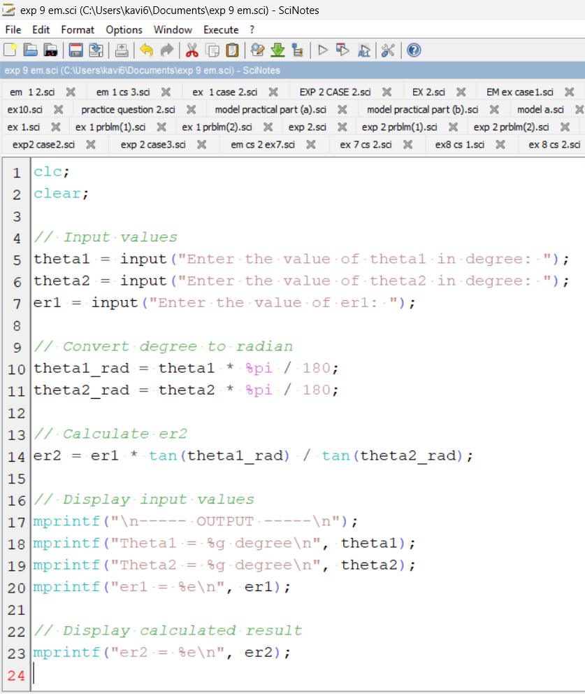
Output:
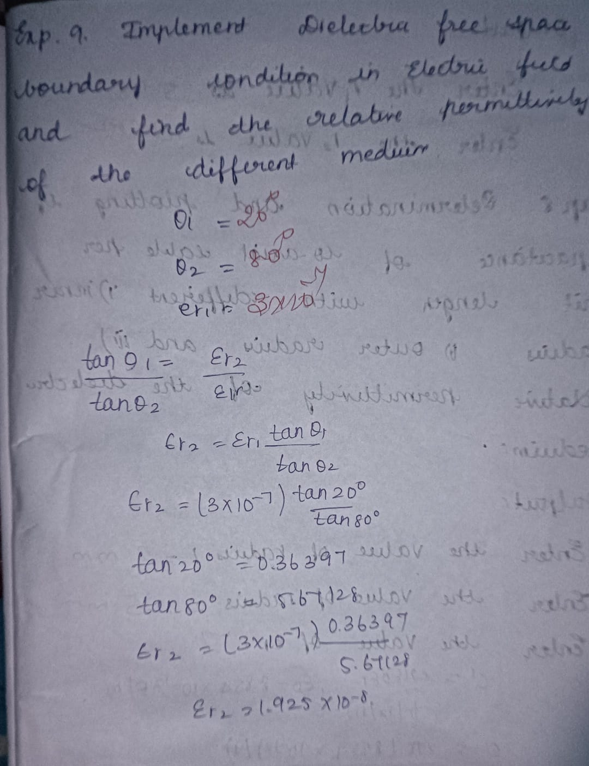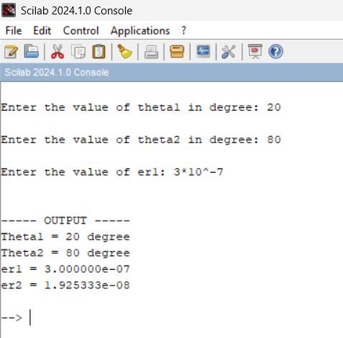
Case 1: In this case, the dielectric medium has a relative permittivity (εr) of 2, meaning the dielectric reduces the electric field by half compared to the free space. This is typical for materials like mica or certain types of plastics. ● Free Space Electric Field (E1): 100 V/m ● Dielectric Electric Field (E2): 50 V/m
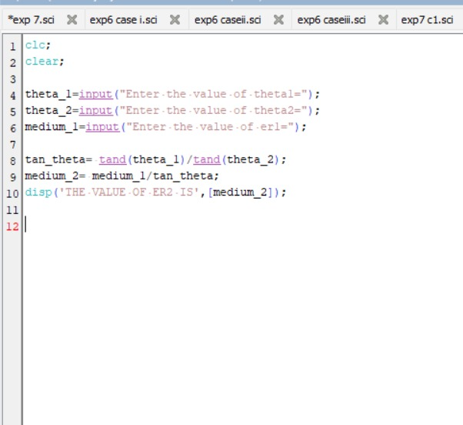
Output:
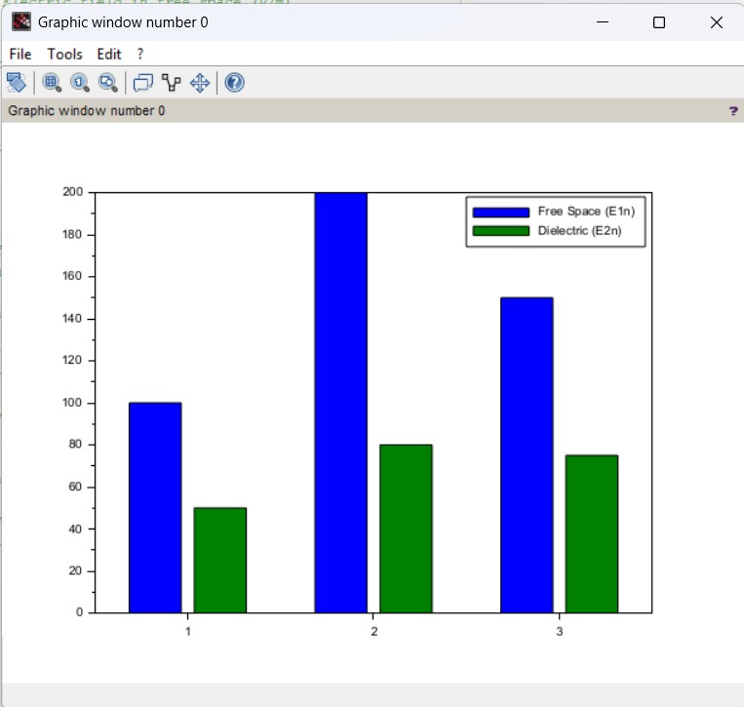

Case 2: Here, the dielectric medium has a higher relative permittivity (εr=2.5) compared to Case 1. This indicates a stronger polarization effect in the dielectric, as seen in materials like glass or water. ● Parameters: o En1=200 V/m (Electric field in free space). o E2n=80 V/m (Electric field in the dielectric medium).

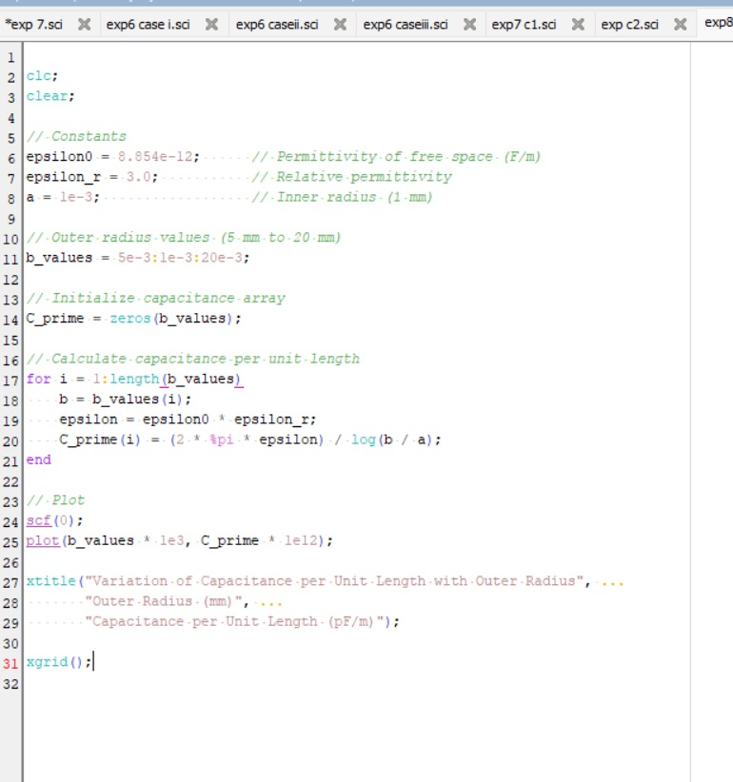
Output:
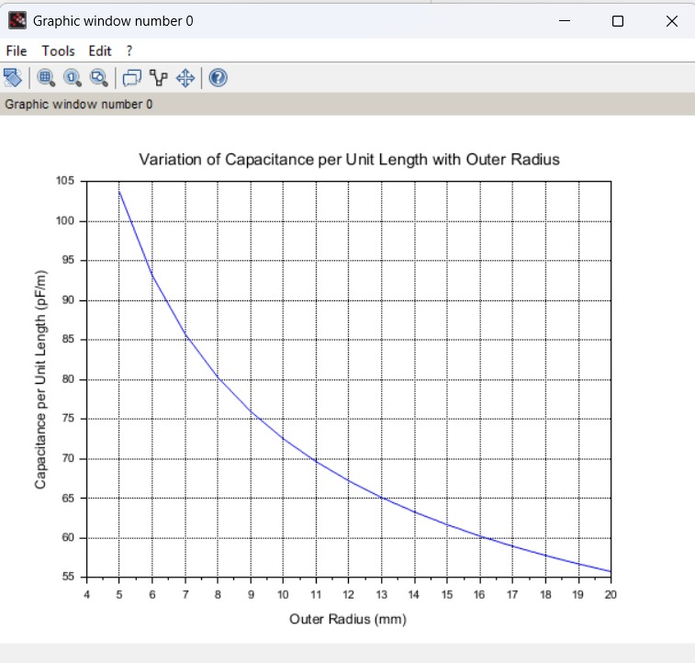
Case 3: The dielectric medium here also has a relative permittivity of 2. The behavior of the material suggests it could be another low-polarization dielectric material, with a consistent reduction of the electric field by half. ● Free Space Electric Field (E1n): 150 V/m ● Dielectric Electric Field (E2n): 75 V/m.
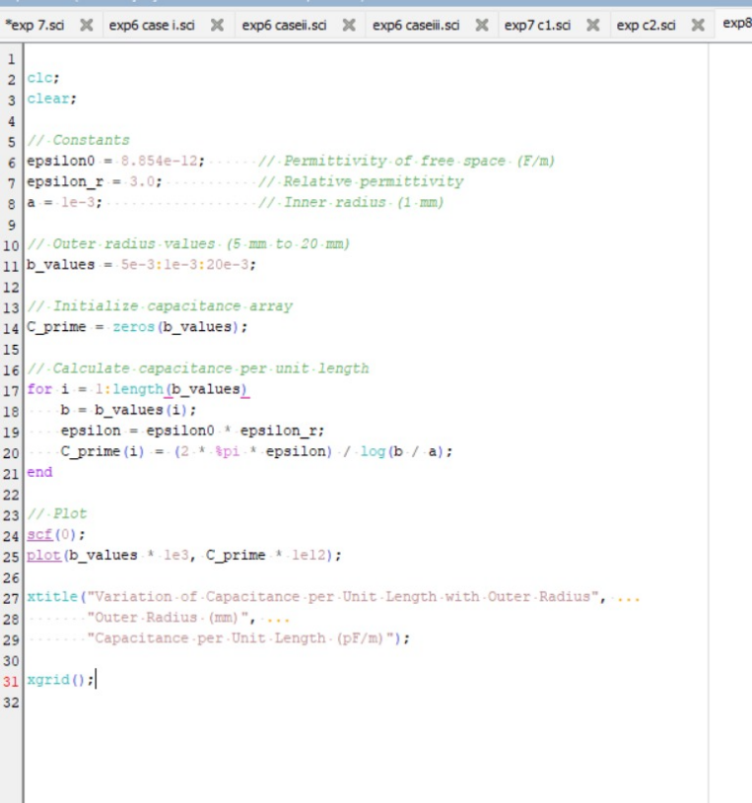
Output:
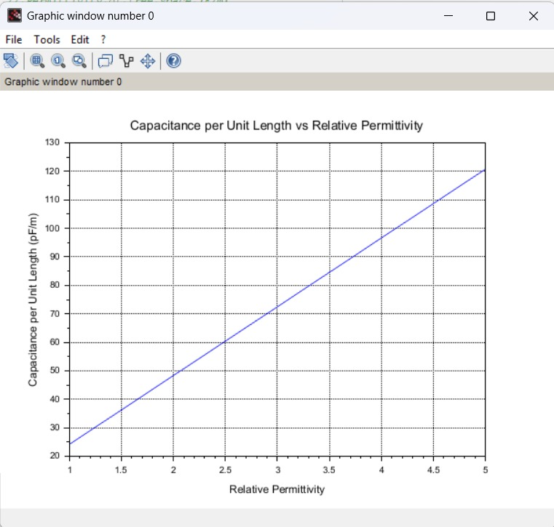
Result : Thus the program was verified for Dielectric - free space boundary condition in Electric field using SCILAB was successfully.

